
SE-401L Human Computer Interaction Lab
Sir Dr. Hamid Ullah
29 Jan 2026
Ali Khan – 23MDSWE248
Humais Ali – 23MDSWE282
Input Output Channels Lab_01
University of Engineering and Technology Mardan

Lab Title

Input Output Interaction

Selected Interactive System
System Name: Google Maps (Web Version)
Type: Web Application
URL: https://www.google.com/maps
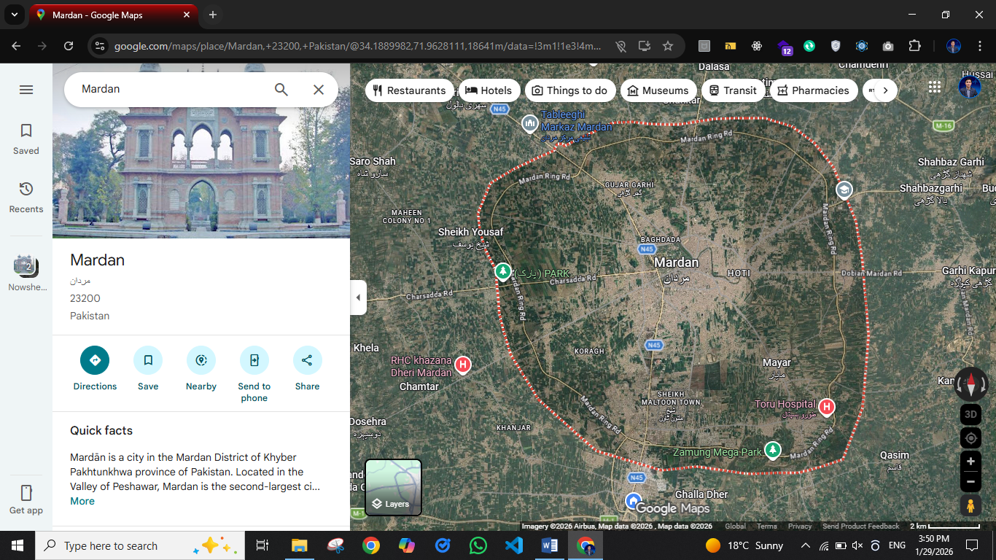

Task 1: Identification of Input–Output Channels

Objective
To identify the human input and output channels involved while interacting with a web-based interactive system.

Human Input Channels Used
- Visual input (eyes): Viewing maps, routes, icons, text
- Motor input (hands/fingers): Mouse clicks, keyboard typing, scrolling
- Auditory input (ears – optional): Voice navigation sounds (if enabled)
- Speech input (optional): Voice search feature

Human Output Channels Required from User
- Motor actions: Clicking, dragging, zooming, typing
- Speech output: Giving voice commands (optional)
- Cognitive output: Decision-making (choosing routes, locations)

Task-to-Channel Mapping Table
User Task | Input Channels Used | Output Channels from User
Searching a location | Visual, Motor (keyboard) | Typing, clicking
Zooming map in/out | Visual, Motor | Mouse scroll / touchpad
Selecting route | Visual | Clicking, decision-making
Using voice search | Auditory | Speech output

Task 2: Interaction Analysis

Observation
Users interact with Google Maps mainly through visual elements, mouse/keyboard actions, and optional auditory guidance.

Analysis

1. Visual Clarity
- Font size is clear and readable
- High contrast between roads, landmarks, and background
- Icons (location pin, directions, traffic symbols) are intuitive and recognizable

2. Auditory Feedback
- Voice navigation provides clear spoken directions
- Alerts like “turn left” are timely
- Audio confirmations are helpful but optional

3. Touch / Haptic Response
- Buttons highlight when hovered or clicked
- Smooth zooming and dragging response
- No vibration (since web version), but visual feedback compensates

Interaction Aspect | Observation / Analysis
Visual Clarity | Font size is clear and readable. High contrast exists between roads, landmarks, and background. Icons such as location pins, directions, and traffic symbols are intuitive and easily recognizable.
Auditory Feedback | Voice navigation provides clear spoken directions. Alerts like “turn left” are timely. Audio confirmations help users but are optional.
Touch / Haptic Response | Buttons visually highlight when hovered or clicked. Map zooming and dragging are smooth and responsive. No vibration is present in the web version, but visual feedback effectively compensates.

Task 3: Usability Issues and Limitations

Identified Problems Related to Input–Output Channels
- Small text at higher zoom levels
  - Street names become difficult to read
  - Affects users with weak eyesight
- Lack of strong feedback for some actions
  - Clicking certain places does not always give clear confirmation
- Excessive motor effort
  - Repeated zooming and dragging required in dense areas
- Audio dependency
  - Without sound, navigation feedback relies only on visuals

Task 4: Sensory Memory Analysis

Interface Elements Relying on Sensory Memory

1. Visual Feedback
- Highlighted routes
- Animated movement of the map
- Color changes for traffic (red, yellow, green)

2. Auditory Feedback
- Beeps and spoken navigation alerts
- Arrival notifications

Analysis of Sensory Cues
- Visual cues are clear and noticeable
- Animations are smooth and not too fast
- Auditory alerts are easy to understand

Missing Sensory Feedback
- No tactile feedback for confirmations
- No visual alert when clicking inactive areas (can confuse users)

Task 5: Short-Term Memory (STM) and Long-Term Memory (LTM) Testing

Short-Term Memory (Practical Examples)
(Temporary information, lasts a few seconds)
- Remembering a route name briefly
- Recalling last searched location
- Remembering a pop-up message
- Noting distance shown on screen
- Temporary traffic alert
- Remembering zoom level
- Reading and remembering instructions
- Holding a landmark name in mind
- Remembering a pin color meaning
- Recalling a turn direction

Long-Term Memory (Practical Examples)
(Stored knowledge, learned over time)
- Remembering how to use Google Maps
- Understanding map symbols
- Knowing traffic color meanings
- Remembering home location
- Familiar routes knowledge
- Learning shortcuts
- Remembering voice commands
- Understanding navigation layout
- Remembering frequently visited places
- Knowledge of zoom and drag gestures

Conclusion
This lab demonstrated how Google Maps effectively uses human input–output channels, sensory memory, and feedback mechanisms. While the system is highly usable, minor improvements in feedback and accessibility can enhance user experience.

THE END

